
PP-0000 Pilot Plant Fire Extinguisher
7/9/2026
Rev. 1

ABSTRACT:
This document is intended to act as a first point of contact for troubleshooting common errors associated with the pilot plant. It is by no means extensive but should get most problems encountered amended. For more extensive information, the most recent documentation was part of a 2023 handover for an honours level thesis, included in that documentation is all preceding documentation. If you have this you have all available plant information.

Contents

List of Figures 3
List of Tables 3
Document Control and Revision History 4
1.0 Purpose 5
2.0 Required Accesses 6
3.0 Of Note Applications 6
4.0 The Common Errors 7
4.1 Control Program Not Running 7
4.1.1 The Controller is Off 7
4.1.2 Controller is Halted 7
4.1.3 Unloaded controller 11
4.2 The Server “PPServer1” is Offline 13
4.2.1 Server Unpowered 13
4.2.2 Server Crash 13
4.3 Controller Level Comms outage 14
5.0 The Hard Ones 14
6.0 The End 16

List of Figures
Figure 1: Experion Station, everything happy 5
Figure 2: Experion station, everything not happy. 5
Figure 3: Experion Configuration Studio application. 8
Figure 4: Configuration studio PPServer1 Experion system initial connect 8
Figure 5: Experion Configuration Studio system root directory. 9
Figure 6: Administer the control strategy database -> Resolve control configuration management lockouts. 9
Figure 7: Experion control builder application 10
Figure 8: Controller/Module level monitoring (left good -- right bad) 10
Figure 9: Change state -> cold start (controller should become green) 11
Figure 10: CMs – if running all should be green except: CSTR_TANKS_OP, CUF_TANK_OP, NT_TANKS_OP, ST_TANKS_OP, TRBSHT_OP 12
Figure 11: Load With Contents -> follow prompts. 12
Figure 12: Testing local station to remote PPServer1 comms. (Above is what you want) 13
Figure 13: The last resort 15
Figure 14: The last-last resort: C:\ProgramData\Honeywell\Experion PKS\logfiles – NOTE: \ProgramData\ is a hidden file by default 15

List of Tables
Table 1: Document Control and Revision History 4

Document Control and Revision History
Table 1: Document Control and Revision History
Revision | Date | Author(s) | Reviewed by | Comments/Details
1 | 2026 | Nicholas O’Keeffe |  | Initial Commit.

Purpose
This is literally the most concise document I can create to try and set you up to be able to trouble shoot likely issues associated with the pilot plant. There are two states of the pilot plant that can be observed from Experion Station.
- Good See all the numbers.
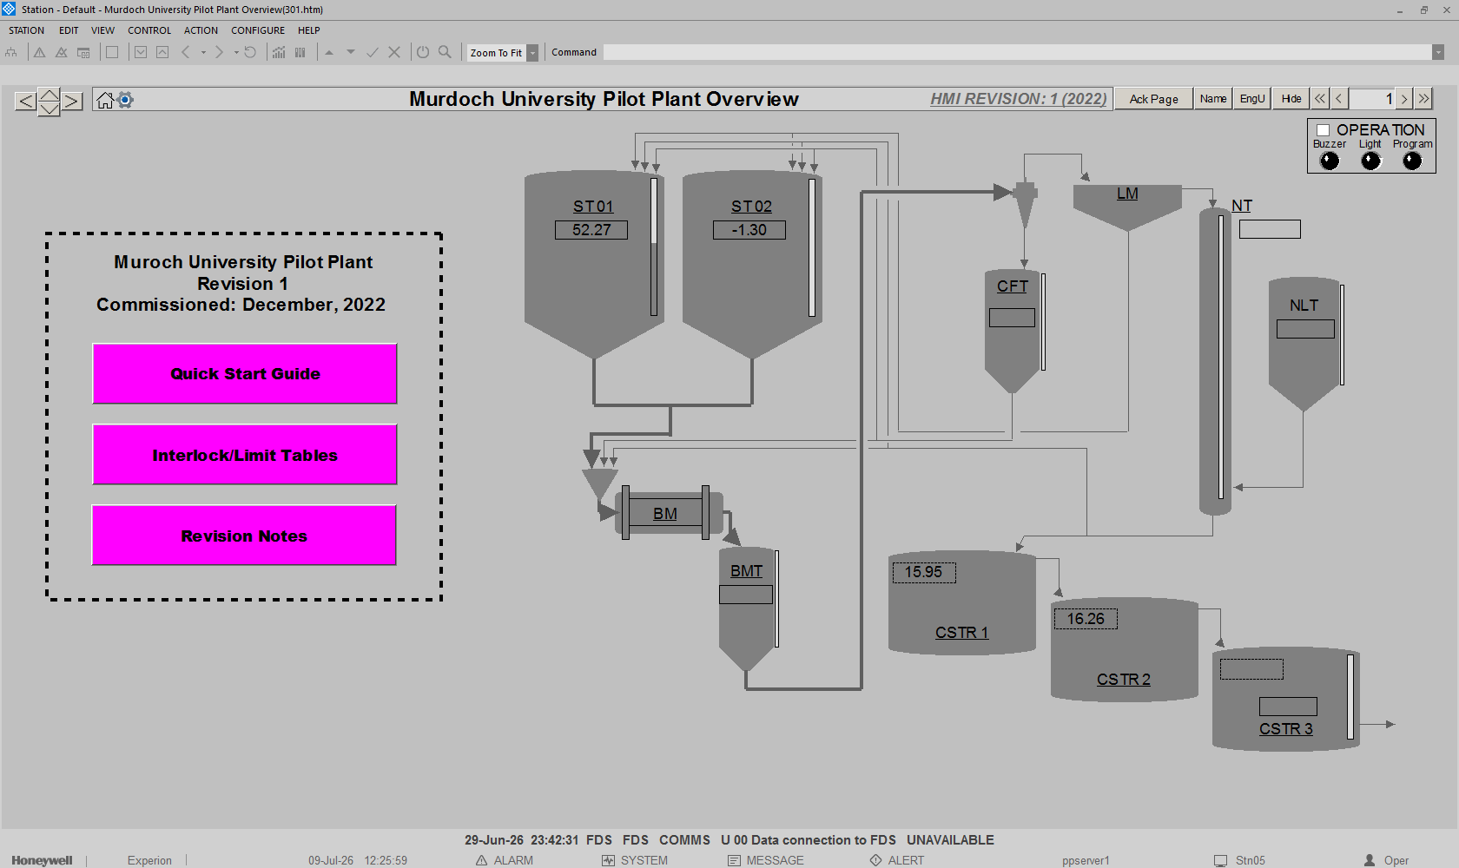
Figure 1: Experion Station, everything happy
- Bad See all the NaNs.
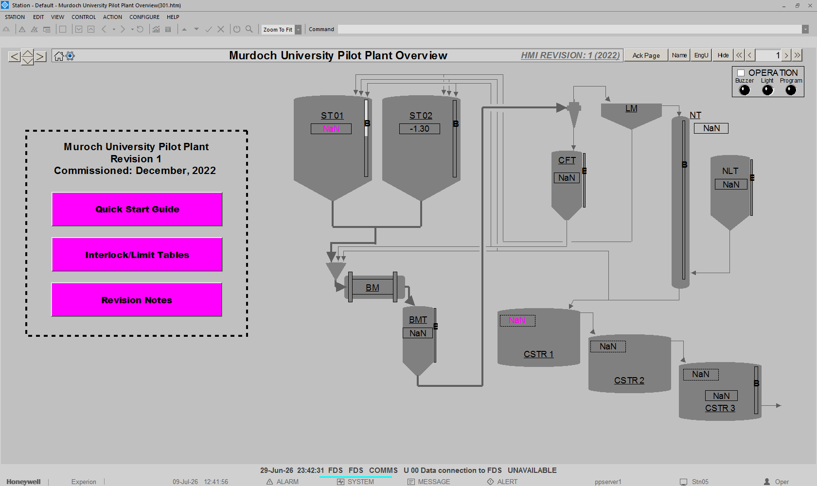
Figure 2: Experion station, everything not happy.

There is a secret third state when nothing comes up at all. The HMI is HTML based, station links to the file path containing the home screen of the HMI, and the home screen has links to the paths of all other screens. If nothing comes up, either:
- The link has broken and Experion station cannot see the home screen – Search through the Experion tool bar to find the properties, find the path field and relink. The file path will begin with:
C:/ProgramFiles/Experion/WebHMI/…
I cannot remember the precise location, but I know I covered it in my thesis which is included with the handover documentation in a file called “2023 Handover”
- The files have been wiped from the computer – In this case you need to get the files from the server computer, these will be stored in the same path as listed above.
So, we’re going to go through the various breaks I’ve encountered, which should cover you for almost all errors, and I’ll cover a few strategies for the occasional novel breaks that come up from time to time.

Required Accesses
To perform the fixes discussed here you will need:
- Engineer level (or higher) access to the Experion Server
- Access to remote desktop connections
- Remote access, specifically to the server
Krishna Arjun can help with number 1., Kris Parker could probably do all three, Kris is very helpful, if he can’t do it, he will tell you how to get it done.

Of Note Applications
The following applications are relevant to troubleshooting the Experion system:
- Experion Configuration Studio – Where SCADA management and design is performed, higher level networking related tasks are performed elsewhere, but pretty much everything is done here.
- Windows Server Manager – Sometimes issues pop up here, but more often, it can point you in the right direction
- Start-Stop Experion PKS Server – Does what it says it does on the tin, never underestimate turning it off and on again
- Experion PKS Services Control Panel – Basically just an Experion specific version of Windows Server Manager
- Experion PKS Server Log – Very much the hail-Mary, if nothing else works this might give us some insight

The Common Errors

Control Program Not Running
A number of things can halt the controller, brief losses of power will cause a reboot, and the controller will always default to a safe state in startup. The controller itself has no non-volatile memory, to get around this there is some kind of internal power storage – a battery or something – but due to its age or batteries just not lasting indefinitely, if the power is lost for too long the memory will lose power and clear (the programs loaded on the controller will be lost). This describes the three primary reasons the control program might not be running.

The Controller is Off
Sort of self-explanatory, go check to make sure there is power in the cabinet. Keep in mind that the controller, once powered will either need to be moved from an idle state or, the program will need to be reloaded AND the controller moved from an idle state (see the next sections).

Controller is Halted
Brief power losses, or certain interlock conditions/errors can cause the controller to enter a stopped state. To restart we need to get onto the server. Either:
- Log onto the server computer
- Remote connect to the server computer – You will need permissions for both remote connections, and specifically remote connection to “PPServer1”
Once connected open configuration studio (Figure 3) – all control/SCADA related programming and configuration are done here. When it opens you will need to connect to the pilot plant system “PPServer1” (Figure 4) – a little confusing, PPServer1 (the computer) is different to PPServer1 (the DCS) – and you will observer the configuration studio root directory (Figure 5). From here you can click on control strategy in the directory and on the right hand side in the colomn of options select “configure process control strategies”. This will open Experion Control Builder, a separate application for control programming.
NOTE: If at any time while using the control builder application an error appears to the effect of “a lock is on the controller” it is because a previous session did not properly disconnect. You will have to manually clear the last user. Back in the directory, again select control strategy, this time, from the right-hand side column of options select “Administer the control strategy database”. When the application opens do the same thing that’s happening in Figure 6.
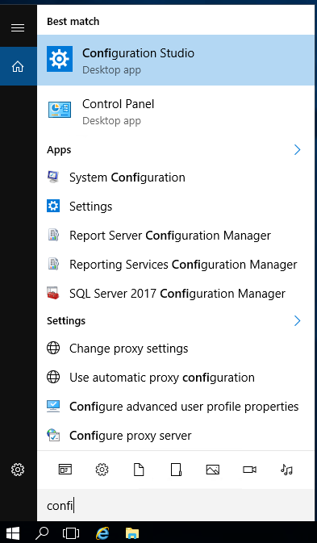
Figure 3: Experion Configuration Studio application.
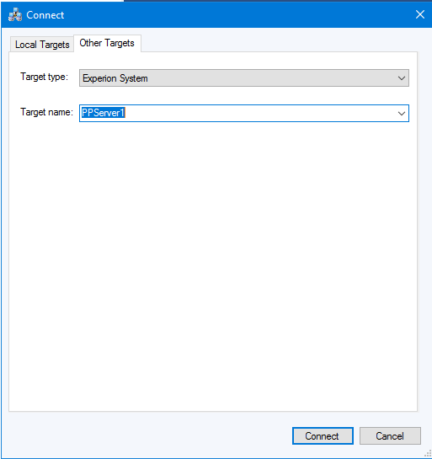
Figure 4: Configuration studio PPServer1 Experion system initial connect
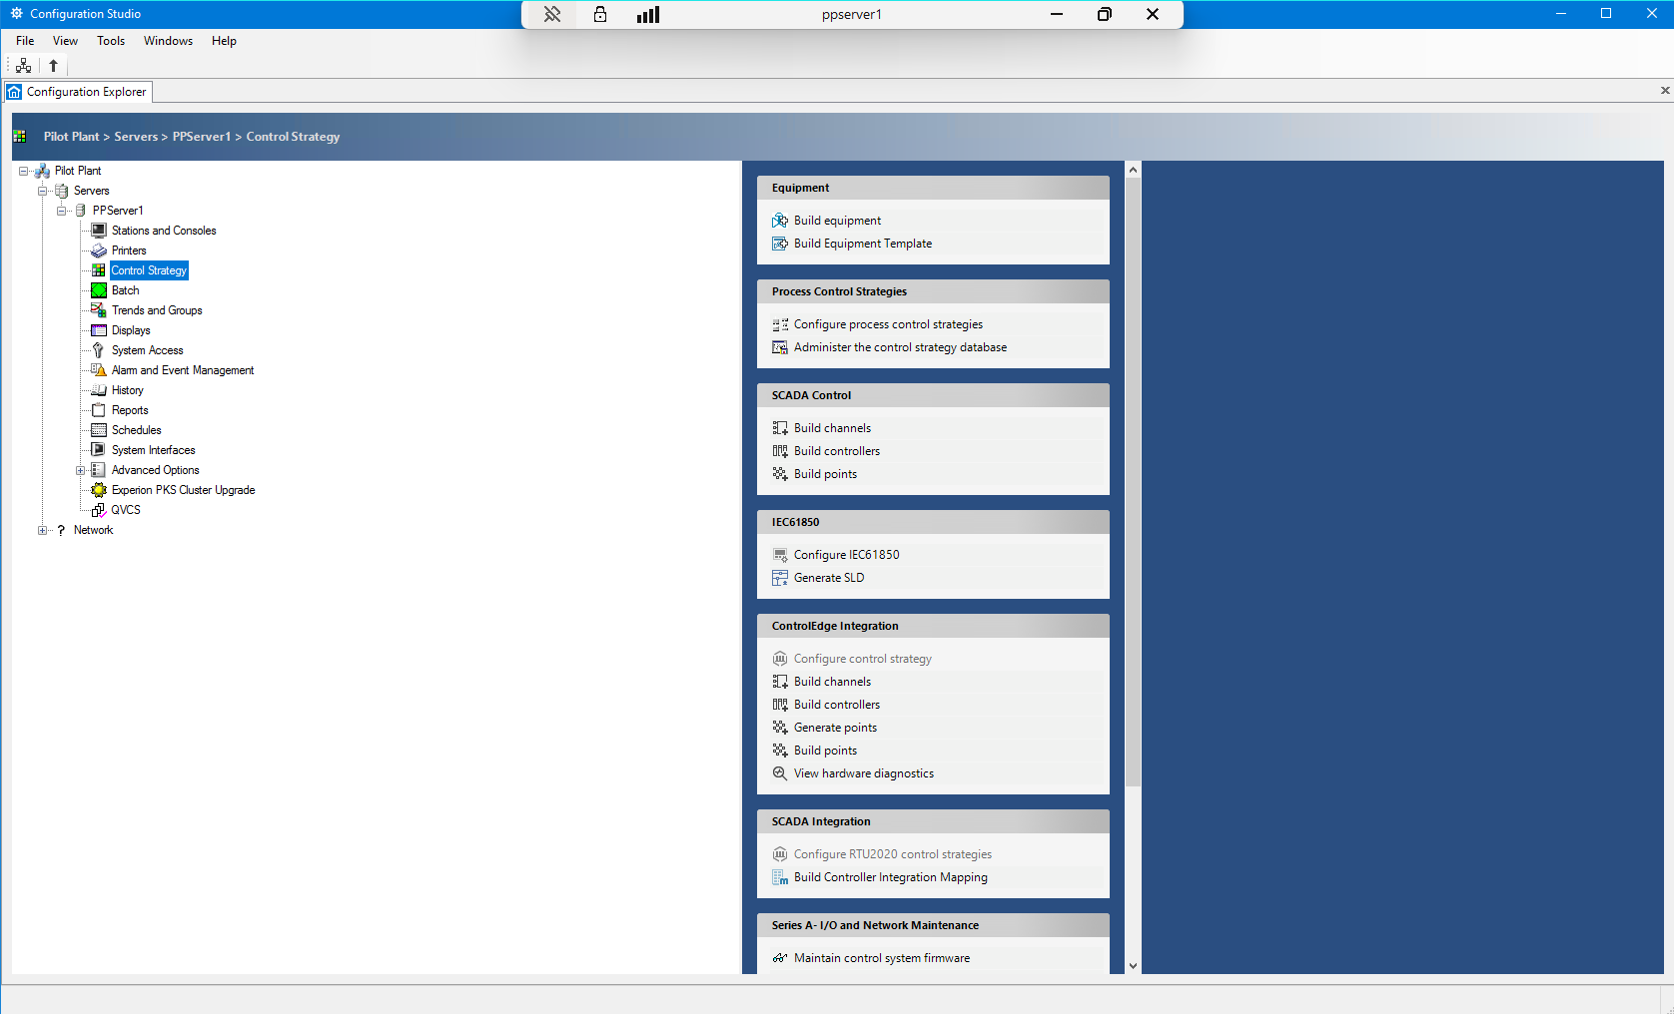
Figure 5: Experion Configuration Studio system root directory.
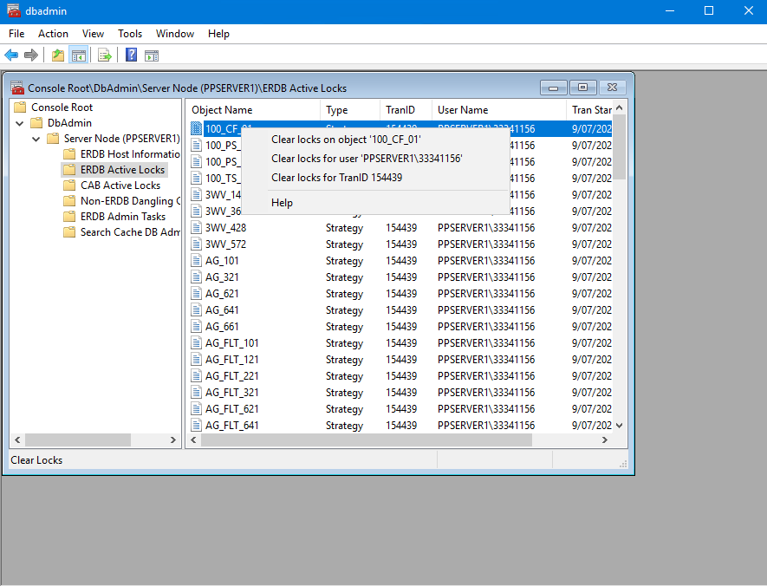
Figure 6: Administer the control strategy database -> Resolve control configuration management lockouts.
Figure 7 shows the opened control builder application. Focusing on the controller “CPM_01”, and the control execution path within it “CEE_01” in Figure 8. Figure 8 left, shows the controller online, running, and happy. Figure 8 right shows the controller online and happy but not running. To start, right click the control execution path, select change state, and in the pulldown menu of the popup, select cold start (Figure 9). At this stage the program should be running, the controller in the control builder application should turn green (it might take a little bit) and everything should be fixed.
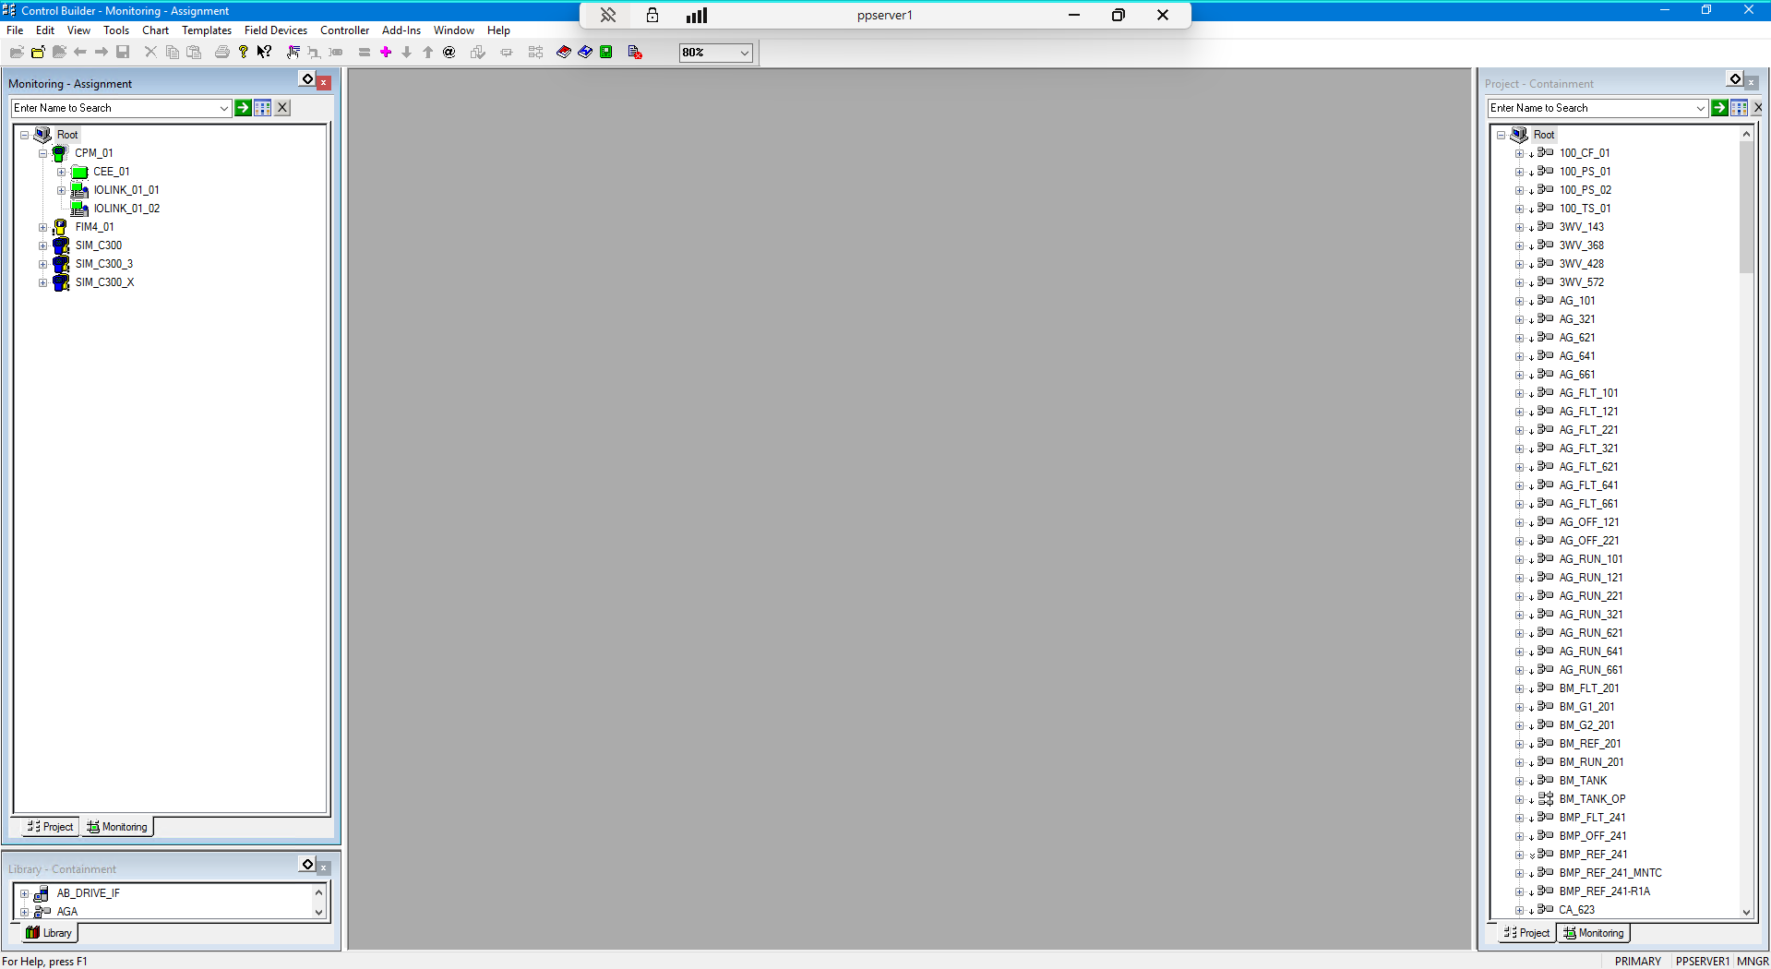
Figure 7: Experion control builder application
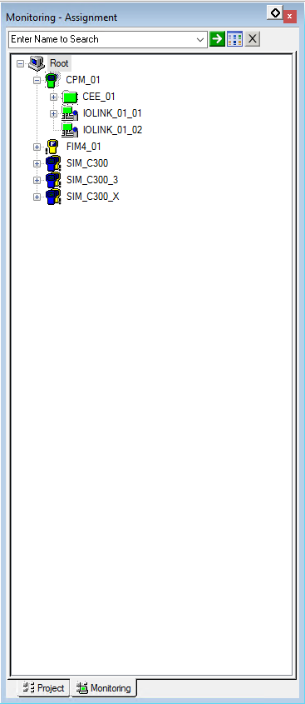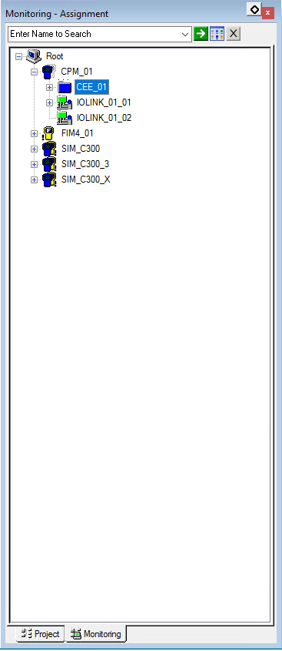
Figure 8: Controller/Module level monitoring (left good -- right bad)
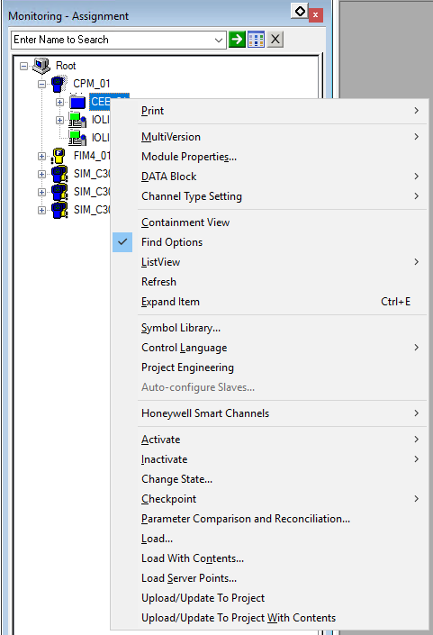
Figure 9: Change state -> cold start (controller should become green)

Unloaded controller
When you open the control execution path in control builder, you should see a list of control modules (Figure 10). If they are green, they are running and happy, if they are blue they are happy but not running – all should be running except:
- CSTR_TANKS_OP,
- CUF_TANK_OP,
- NT_TANKS_OP,
- ST_TANKS_OP,
- TRBSHT_OP.
If they are red, it means there is an inequality between the configured program on the server, and the program on the actual controller, i.e., the program is not loaded. To fix this, right-click the controller “CPM_01” and select load with contents Figure 11. Follow the prompts, reload all CMs (this will take quite a while) and follow the process from the preceding section to start the controller.
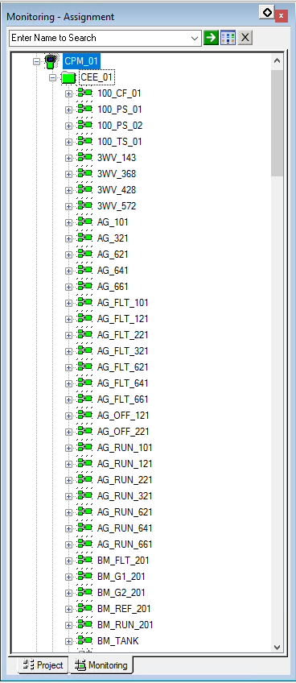
Figure 10: CMs – if running all should be green except: CSTR_TANKS_OP, CUF_TANK_OP, NT_TANKS_OP, ST_TANKS_OP, TRBSHT_OP

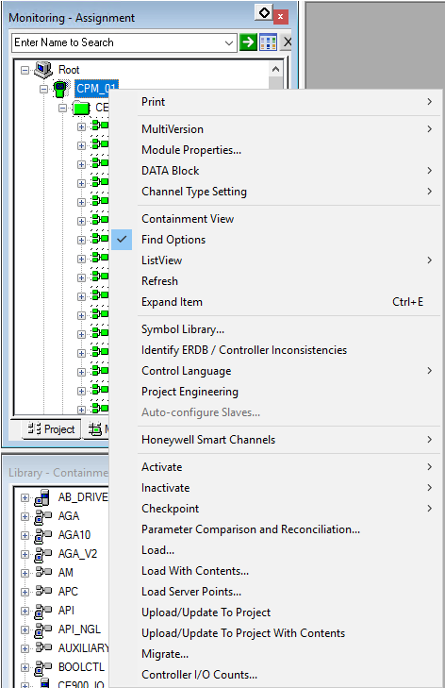
Figure 11: Load With Contents -> follow prompts.

The Server “PPServer1” is Offline
When we cannot see the server, two things could have happened:
- The server is offline – this section
- The controller is offline – the next section
The easiest way to check which it is, is run a port scan in PowerShell (Figure 12). Check connection to ports 2909 and 2910 of the server from your local machine. If these show connection the issue is comms with the controller (next section), if these fail the issue is connection to the server (this section).
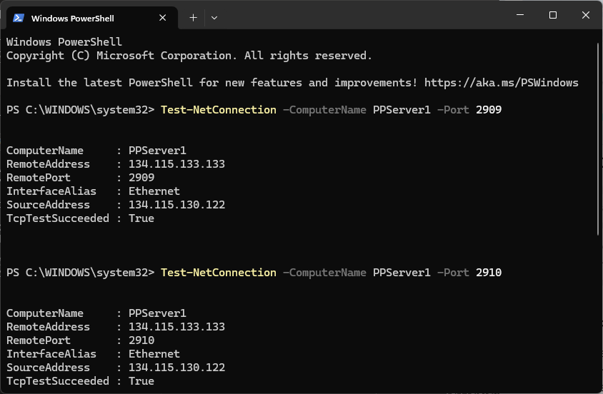
Figure 12: Testing local station to remote PPServer1 comms. (Above is what you want)

Server Unpowered
Again self-explanatory, just restart, as long as the controller didn’t hit stop conditions, you won’t have to do anything else.

Server Crash
Open a different application from windows “Start-Stop Experion PKS Server”. It’s a very simple program, power cycle the server and see if it fixes it.
NOTE: With any server level issues investigate the windows server manager, often errors listed in this application will tell you the issue or at least point you in the right direction. Unfortunately, there are a couple of errors that are almost always happening regardless of function, so don’t assume you have found the problem if you see an error.

Controller Level Comms outage
This is either the easiest or hardest one to fix, in all likelihood, an ethernet cable is unplugged somewhere. Start by pinging the controller to confirm a comms outage. Check the runs from the back of the server, through the switch in the western most corner of the room down the length of the room to a socket on the wall. If the switch is powered and the run is fine, go down to the cabinet that houses the controller. There is an ethernet port on the right-hand side of the cabinet, check that connection and follow the run to a socket on the eastern most corner of the room. If these connections are fine check inside the cabinet. The terminating socket on the right-hand side of the outside of the cabinet is passed through before connecting to the controller. If all of these are fine it could be a damaged building connection, but it is more likely something from the next section.

The Hard Ones
At this stage if nothing is working it is safe to say it is either an IT level problem or some miscellaneous other issue. In either case it can be tempting to get IT involved, we will likely need to, but it can be worthwhile performing further investigation first. IT are very good at IT, but there OT skills are limited, and they can be quite standoffish when it comes to taking suggestions. If you can approach them with a specific problem it will get resolved much faster.
Any of the server level issues mentioned above could be a result of something IT related, often these are caused when system updates occur, a port will become locked, etc. So long as we can access the server in some way we can perform some diagnosis.
Start by inspecting the logs in the “Experion PKS Server Log” application (Figure 13), it can be daunting, but it often gives information. You will often be given codes that don’t seem to mean anything, but there is the user assistance application installed on the computer that you can copy and paste these codes into for further assistance.
If this yields no results, the last-last-resort is the investigation of .txt log dumps of the system (Figure 14), located in the path:
C:\ProgramData\Honeywell\Experion PKS\logfiles
NOTE: \ProgramData\ is a hidden file by default so you will need to go to view in the windows file explorer toolbar to unhide all files.

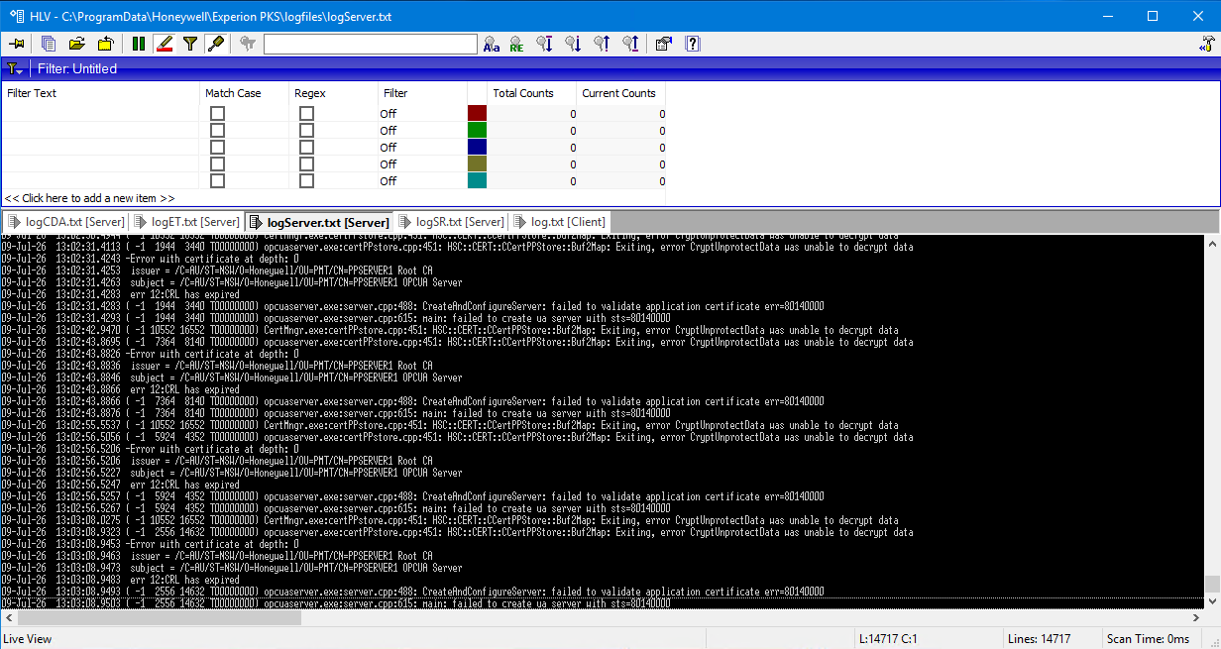
Figure 13: The last resort
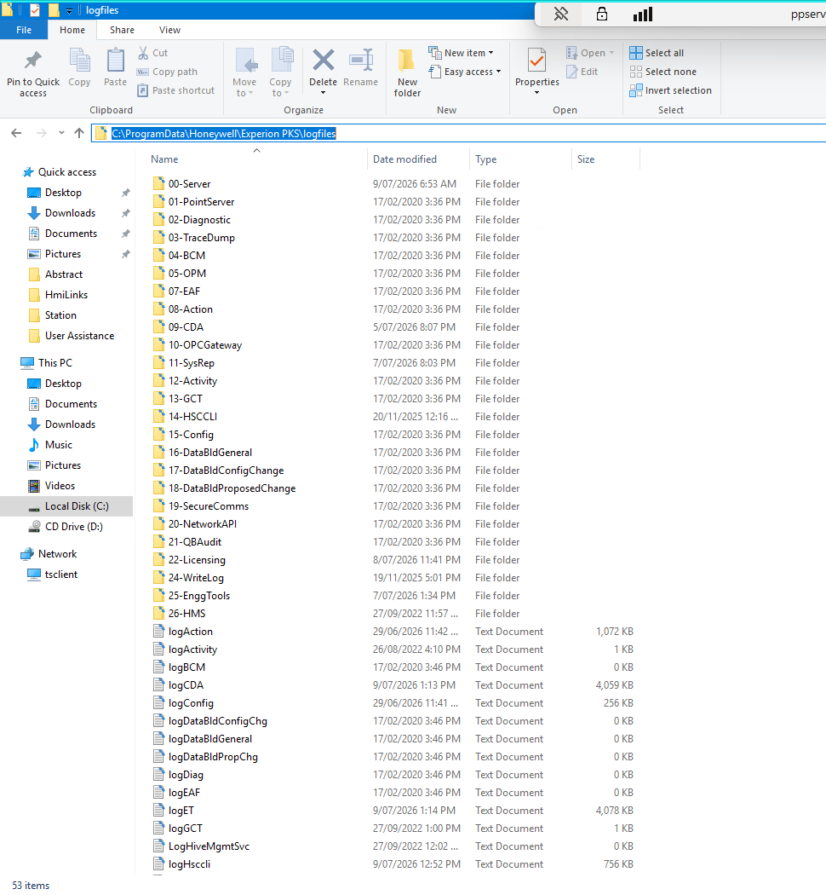
Figure 14: The last-last resort: C:\ProgramData\Honeywell\Experion PKS\logfiles – NOTE: \ProgramData\ is a hidden file by default

The End
If you are still stuck call for reinforcements:
- Kris Parker is very good
- IT are genuinely very helpful if you approach them with some useful information, the things you have tried, where the break is if you have found it (e.g., station -> server), etc..
- Email/Call me, someone will have my contact details
The gold standard is Will Stirling, he retired 5 years ago, but he is very lovely and if you reached out he would probably drop everything to help. If there is any break, he’ll fix it.

